### Nurulogo

**2012 ANNUAL REPORT**

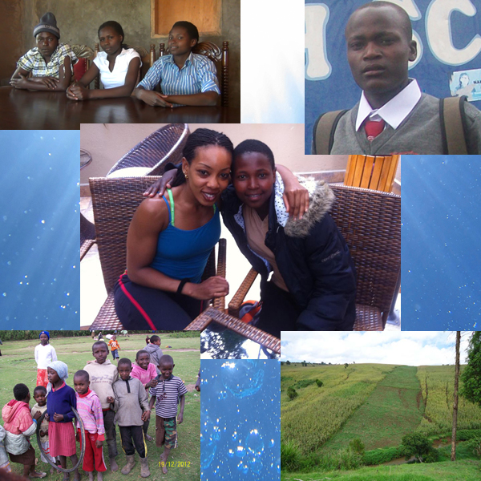

Word from the Executive Director:

As I reflect on the Nuru Center’s accomplishments in 2012, my heart is filled with humility at the trust and confidence that is bestowed upon our organization by donors, volunteers, and supporters alike. Nothing, absolutely nothing we do could be possible without this confidence and trust. It is our commitment to continue to honor this trust as we stay on track changing lives, one child at a time!

In fiscal year 2012, Nuru Center celebrated many achievements. 2012 saw our fourth year of the Elimu Scholarship program and the graduation of the first class of the scholarship recipients. We are proud to announce that three of the five graduates - Susan, Carol and Emily - earned the minimum requirements that will see them selected to Kenya’s public university system – an opportunity that will continue to change their lives; something that would not have been possible without the generosity of our donors and dedication of our volunteers! Thank You!

We diligently continue to work on our long-term goal of self-sustenance. In 2012 we made progress towards this goal with the purchase of a 5-acre farm. The farm is the first of several strategic plans towards self-sustenance. Our goal continues to be that in 5-7 years, we can generate 65%-75% of our operational goals from several strategic projects.

As in past years, the Kikapu program was again successful. With one of our volunteers from California, Mercy Mutua, dedicating a week out of her personal vacation time in Kenya to get on the ground and lead the efforts. Not only did she take the time, but also galvanized local support for the program for the second year running. This is just but one example of the many sacrifices and dedication we get from our volunteers for which we’re ever grateful. We’re thankful to each volunteer here in the US and back in Kenya for your dedication towards our mission of changing children’s lives in rural Kenya.

Nuru Center is proud to have achieved everything in 2012 with 100% of the efforts, both in the US and in Kenya, on volunteer basis – no paid staff! In addition, the board continues to give towards administrative costs meaning that 100% of your donations continue to go towards the programs and strategic projects.

In 2013, we plan on growing our existing programs as well as continue to work on our long-term strategic goals. In particular, we hope to increase the number of people who directly sponsor the children through our Elimu scholarship. Not only will this enable us to impact more families, but it will also ease the financial burden and allow us to devote more resources on our strategic goals. Our next major strategic goal is to open a community center in the rural area of Molo. We believe we can impact more children from a young age and the community at large with well thought of programs in the community center.

Our focus remains on the children from poor backgrounds in rural Kenya. Our dedication to the mission is stronger than ever. Above all, we understand that we cannot achieve anything without the trust and confidence of our donors and corporate partners. Towards this, we pledge to continue being open and transparent in our transactions.

In this annual report, you’ll get detailed reports on the status of our programs as well as our future plans. We continue to highlight our scholarship recipients; it is their stories that remind and inspire us to continue the fight against poverty in rural Kenya. It is the joy of seeing the lives of most, if not all of them, changed forever that makes our efforts worthwhile.

Finally, please read the letter from a volunteer from the US who’s been on the ground to see the work Nuru does. Mercy Mutua narrates her experience sharing with us snippets of the needs we seek to fulfill but also the joy and humility that giving and volunteering brings. Mercy’s story is on the next page. If you don’t read anything else in this report, read her story.

On behalf of the Nuru Center board and beneficiaries, thank you for your continuing support of our mission. You continue to make a real and positive impact on the lives of many children and community at large. Without you, there’s no Nuru Center. We look forward to continuing this partnership changing lives, one child at a time!

Shem Orwenyo

Executive Director and Founder,

**A volunteer’s Perspective**

By Mercy Mutua,

I have tried to make it a tradition to visit my family in Kenya every December. It happens to coincide with the Nuru Centers Kikapu project is held in December. I first volunteered for Kikapu in 2011. My friends and family who only see me one month out of the year were happy that I was going to help the needy but they did not want me gone for a “whole week”.

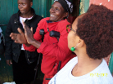My friends who had previously volunteered for Kikapu were teasing me telling me that “Mercy the diva “wouldn’t make it because the dust was out of this world, the sun was blazing hot, we were out in the field all day, the Vikapus(baskets) were heavy…. I had to mentally and physically prepare myself for Kikapu. I SURVIVED!!! And came out of it with a humbled heart, grateful for every meal and the love I get from my loved ones. I knew I had to volunteer for Kikapu again.

2012 was not as dramatic to prepare for. My family knew that I was going to be gone for four days and not a week. My friends had nothing to say because I had survived 2011. We had fewer volunteers than the previous year but our commitment to the cause made up for the labor and the work went on smoothly. The work begun the day we arrived in Molo. Our challenge this time was going to be the muddy roads, the rain and the cold. We bought and packed the food on the first day and delivery and meeting the families began the following day. Visiting the sick in the hospital was the on the last day.

As always the neighborhood children were following us as we delivered the Vikapus. These children who also do not have much are full of joy and smiles when given a piece of candy. That one piece of candy might be the only Christmas gift they get. I always feel like they have lived longer lives than their short years because of all the injustice they have seen from the adults. Many of them are kids talking care of kids. Seeing a girl as young as five carrying her infant sibling on her little back was the norm.

The Kikapu recipients are always thankful and most of them are left tongue tied because they can’t believe that there are other human beings who care enough to share with them. Many of them burst out in song and dance. Nuru center Volunteers have to be emotionally prepared because one minute you are crying and the next you are singing and dancing!

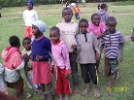Some of the situations we saw still haunt us. We visited families were children had been neglected by their parents. These children had not eaten all day and if we had not been there they would have gone to bed hungry. Some homesteads were so poor that the despair in that place felt tangible, the air felt like it needed more oxygen. A couple of times we had to collect money amongst ourselves to buy bread for the people because we did not have enough Vikapus.

We also met Women who had taken matters in their own hands because their drunken husbands were not of any help. They had started small businesses like chicken farming and selling veggies. These women were previous recipients of Kikapu. They shared how the kindness of other people had given them hope.

2012 was a great year of achievement for Nuru Center. We had the Elimu Scholarship recipients’ first graduating class. These students also volunteered for the Kikapu project. The girls helped in the kitchen cooking all day for us and the boys were out in the field with us. The boys were such an encouragement to the children in the neighborhood. They spoke to them about working hard in school and never giving up.

We also bought a farm, a beautiful farm. It is on a hillside near a water creek. The farm was rich with potatoes, peas and beans. Harvest time was just around the corner. After seeing all the poverty and feeling like a Christmas basket was a great idea but short lived, seeing the farm was an encouragement to us. It was a step closer to changing the lives of so many poor people in Molo.

Nuru Centers Motto is changing lives…one child at time. I did not know that I would be one of the children. Volunteering for Kikapu has changed my life in that it has given me hope that despite all the poverty, corruption and abuse, things in Africa can change. I have seen them change by becoming a Nuru Center volunteer.

# 2011 Achievements

### The Nuru Center Elimu Scholarship – The First Graduates

2012 was a very important year for Nuru Center. It is the year when we start seeing the fruits from the investment we make thru the Elimu Scholarship program. It is with pleasure to announce that the first five recipients of the Elimu Scholarship program completed their high school education. Most importantly, three of the five students – Susan, Carol, and Emily - earned themselves a chance to be admitted to the public university by attaining the minimum grade and points in the national exam (K.C.S.E).

What does admittance to the public university mean? For one, their lives have been changed and they get an opportunity to continue to change for the better – which is our mission. Two, they will get university education at a subsidized cost as compared to those going to parallel programs in the same colleges or in private colleges. Three, it opens the door for Nuru Center to be able to continue supporting them and fully realizing the change in their lives we sought from day one.

The five students who graduated are Susan Wangui (B+), Carol Nyanchama (B-), Emily Apuke (C+), Keith Monica (C), and David Nyangweso (D). While we celebrate the top 3 students for earning an opportunity to be admitted to the publish university, we have to remember that our focus in the first two years of scholarship award were solely based on need. We only started incorporating the academic consideration on our third year. This gives us hope that we can achieve 100% university admission rate with our future graduating classes.

Below are the profiles and results of the five graduates:

**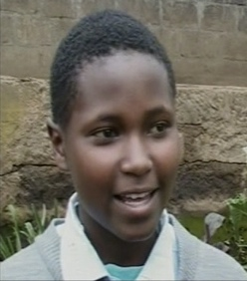Susan Wangui – B+**

Susan is a 17 year old who lives with her mother and three siblings. She has never known or met her father. Often she was forced to miss school to care for her younger siblings while her mother looked for work. Susan took and passed her KCPE 2007, but she lacked the money needed to pay for secondary school. However, she was determined to get an education. Susan repeated 8th grade even though she knew her mother could not afford secondary school and didn't know how she would pay for high school if she passed the 2nd time. Susan’s goal is to become a doctor and research a cure for HIV/AIDS in order to help others who are in her situation. Susan graduated with a B+ and is eligible to be selected to the public university system in Kenya.

**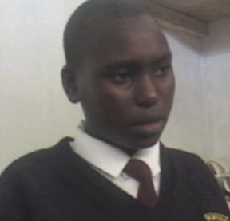Carol Nyanchama – B-**

17 year old Carol Nyanchama Monari is one of 5 siblings born to a single mother, who is disabled and unable to work. In 2005, her mother took her youngest sibling and abandoned Carol and her sister. The girls went to live with an aunt but were expected to work to pay for their share of the rent. Three months later Carol and her sister were kicked out of the house, because they were unable to earn the rent their aunt required. The girls then moved in with a cousin. Every weekend these girls worked all day on a farm to earn money for food. Carol dreams of becoming an engineer and helping others in need. Carol graduated with a B- and is eligible to be selected to the public university system in Kenya.

**Emily Apuke – C+**

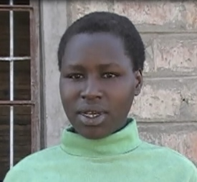When we selected Emily, she lived with her father and stepmother. Her mother died when she was very young. Emily’s stepmother did not support education, making it difficult for her to study. Because of her test scores, Emily’s teachers encouraged her father to find a way to pay for her secondary education, but he was unable to make enough money for the fees, uniforms and books. On many occasions after joining high school, Emily missed school due to lack of school fees or had to walk 6 miles one way to get to school. Unfortunately, Emily’s dad passed away in 2011 and the step mother did not want to live with her. She was taken in by one of the Nuru volunteers and still stays with them. Emily wants to become a doctor. Emily graduated with a C+ and is eligible to be selected to the public university system in Kenya.

**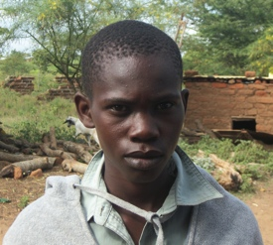Josphat Keith Monica - C**

17 year old Josphat Keith Monicah lived with his grandmother in Kitui at the time of receiving the Nuru Scholarship. His mother abandoned him when he was 2 years old. Because of his grandmother’s age, Keith has been mostly responsible for earning money and taking care of his grandmother. They are so poor that they sometimes go days without food. Keith did not get his first pair of shoes until he was in the 7th grade. Keith was so determined to go to secondary school that he sold the family’s only possession, a goat, to cover some of the school expenses. His plan was to show up at the school with a few supplies and beg the principal to allow him to start school without the required tuition. In his 2nd year of high school, he came back home to find his grandmother had moved because she had gotten too old and needed to be taken care of. Josphat has since been taken in by a Nuru Volunteer. Josphat. He graduated with a C.

**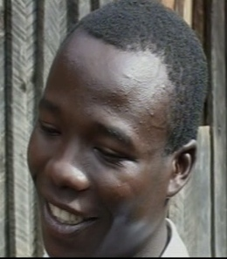Daniel Nyangweso - D**

Daniel Nyangweso was born to farmer parents, as one of 3 siblings. When Daniel was a little boy, his father died in a tragic car accident. His mother died soon after, leaving his sister and him to live with his older brother. His brother was eventually kidnapped and killed. Following his death, the man who employed Daniel’s brother was willing to care for his sister. Daniel was left to fend for himself. Daniel’s dream is to finish school and become a lawyer. Not only is Daniel a beneficiary of the Elimu Scholarship but he has been taken in by one of the Nuru Center volunteers while he attends secondary school. Daniel graduated with a D.

**Current Elimu Scholarship Recipients**

|  |  |
| --- | --- |
| **johnJohn Jane Kariuki**  20 year old Jane John Kariuki lives with his mother and four younger siblings in one small rented room. His mother is a casual laborer and barely makes enough to pay the rent. The children, sometimes, have to go days without food. Jane John started primary school prior to the government introducing free elementary education. His mother could not afford the fees, so he had to quit school. Once free primary education was introduced in 2003, John enrolled and repeated 2nd grade at the age of 11. He was older than the students in his grade but he embraced being a leader and became a role model. He has a deep appreciation for health issues and was elected Secretary of the Health Club in his primary school. John is in the 3rd year of secondary school and his dream is to become a neurosurgeon and help his family and members of his community. | jackson mwangangi **Jackson K. Mwangangi**  16 year old Jackson Mwangangi and his little sister live with their alcoholic uncle. The children’s parents died when Jackson was three years old. His uncle does not encourage the children’s education. When Jackson was in the 8th grade his uncle wanted him to quit school so that he could work and bring home money. Jackson is in the 3rd year of secondary school and his goal is to finish university and find a job so that he may help other orphans, victims of HIV/AIDS and the mentally challenged. |
| chepkemoi**Veronica Chepkemoi**  Veronica comes from a single parent home where the mother does not value education. She was picked for a scholarship when an opening availed itself after another recipient decided they did not want to go to school. Veronica was already missing school because of lack of fees. The little money she had saved from you stint of casual labor was not enough to pay for her fees. She says she’s eager to learn and become someone important in the community. | **Michael Wang’ombe**  michael15 year old Michael lives with his mother and three siblings. Their father died in 2005 leaving their mother with four young children. The mother is a casual labor who takes on odd jobs to provide for the family. Michael’s older brother dropped out of school in the 6th grade to help provide for the family while his older sister was married young without the chance of finishing her school. Michael will be the first child in his family to have an opportunity to attend secondary school. He aspires to be a computer technician. |
| **Janipher Muhonja Amoi**  janipherA mild mannered and soft spoken 15 year old Janipher has been brought by her grandparents after her father died in 1997. She struggled to finish her primary education as she missed chunks of time while she worked to provide basic needs for herself and aging grandparents. At times she accepted clothes and food from her fellow students. She feels abandoned by her mother who remarried after her father’s death and has never checked up on her. She aspires to become a doctor. | maureen**Maureen Wairimu**  15 year old Maureen is an orphan. She lives with her grandmother. Her mother died of HIV/AIDS and she has never known her father. Her grandmother ensured that she finished her primary school education but cannot afford to take her through secondary school. Maureen aspires to be a pilot as well as helping orphans; she hopes to build a children home in the process. |
| **Daniel Abuguza**  abuguza14 year old is an orphan who lives with his aging grandmother. The grandmother also takes care of his elder sister but his younger brother is under the care of an uncle in a different part of the country. Because of poverty, the grandmother cannot always afford to pay for his sister’s secondary school education. She is therefore forced to do casual labor to help out. Daniel is an ambitious boy who aspires to be a doctor | **Maureen Kavindu**  kavinduMaureen is one of five children in her family. With the father moving to the city to sell used clothes for a living and a mother who is sick and spends most of her time in the hospital, the family finds it hard to make ends meet. The older siblings are constantly sent home from school due to lack of school fees because the money the father makes goes towards their mothers medical expenses and basic needs. Maureen aspires to be a teacher or an optician and hopes to use her success to give back to her community. |
| richard_pic**Richard Kimani**  16 year old Richard had already been admitted to secondary school but could not attend due to lack of school fees due to his father’s drukardness and negligence. While he has both parents, his father is a drunk who does not take care of the family leaving the load to his mother. His father works in a hotel where he eats and does not bring the family any food. He spends his salary at the bar. For most days, Richard survives on one meal but managed to pass his national exams the second time around to be admitted to a very good school. He aspires to be a pilot | **Alex** Alex is an orphan whose father passed away from AIDS and the mother is bed ridden with complications of the same. His elder sister and brother did not have a chance to attend high school due to poverty in the family. The elder sister had to get married young and Alex missed many days of school to help feed the rest of his family. Despite all these, Alex passed his KCPE with 344 marks as was selected to a good high school.  . |
| **Hannah** Hannah is also an orphan whose dad passed away in 2004. The mother earns less than $2 a day and has four children to support. The family sometimes sleeps hungry and under the threat of eviction when the mother cannot raise enough funds for rent. Hannah passed her KCPE with 342 marks and was selected to a good high school. | **Purity** Purity comes from a polygamous family. The wives are responsible for taking care of their children. Her mother has 4 other children and her elder sister who's in high school spends a big chunk of time at home because they can't always afford to keep her in school. |
| **Hezron** Hezron comes from a divorced family. The mother earns less than $2 a day. He scored 352 points in KCPE. He was selected to go to a good secondary school. However, his mother could not afford to pay for his school. He therefore decided to go back and repeat class 8 in hope that he would have better luck the following year to get some assistance. Four weeks before the end of the first term, a good Samaritan decided to sponsor a child thru Nuru Center. We found Hezron in class and got him a nice secondary school and enrolled him. Because of this, Hezron has gotten his one year back and his life is on the path that will change it forever. | **Justine** Justine is 1st of 7 children. The parents are poor. He scored 333 points in KCPE. Justine share similar story as Hezron as in he passed well enough, was admitted to a good secondary school but could not attend due to lack school fees. He had decided to attend a local day school that would not have afforded him a good chance to proceed to the university. As with Hezron, a good Samaritan chose to sponsor him later into the first term and Nuru Center worked with his primary school teachers to get him into a good school. |

### 

### Nuru Center Holiday Kikapu Mission

The Holiday Kikapu program is the longest running program under Nuru Center. The outcome for this program has been consistent over the years. “The volunteer’s perspective” on the 2nd page offers a great narration of the 2012 Kikapu program. If you haven’t I encourage you to read Mercy’s report; it captures a lot that we in Nuru Center see and use to drive our mission and plans.

The benefits from the 2012 Kikapu program are as follows:

* We distributed baskets of food to 85 needy families. This is equivalent to over 3400 meals; the baskets can feed a family of four for at least 10 meals. This brings the total meals distributed through this program to over 20,800 to more than 420 families and over 180 patients in the last 7 years.
* We distributed food (fruits, bread, milk, yogurt etc.) to 40 inpatients at Molo Hospital.
* Provided an economic boost to the poor mothers and grandmothers at the local market by making lump sum purchases they rarely see. This is turn blesses their families.
* Most importantly we continued to learn a lot about the community we serve from the feedback we get from the volunteers as they talk to the people in these areas. This information is invaluable in helping us understand the needs of the community and in planning future programs that can help the community rise from poverty.

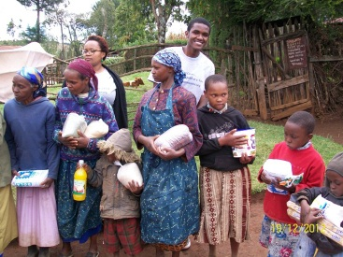

# The Future

### Focus on Children and Sustainability

### The future nonprofit organizations have to be self-sustaining to survive and fulfill their missions. This is a fact that the Nuru Center founders and leadership realized from inception. That’s why Nuru Center was started with a short term, mid-range, and long-term strategic goals.

Nuru Center has achieved most of the short term and mid-range goals. The Elimu Scholarship program is successful and gaining momentum. As detailed in the Elimu Scholarship section, the first five recipients graduated in 2012. We have two students graduating in 2013 and another 13 more on track to graduate from high school in the next 3 years. We have a mentorship program to support the Elimu Scholarship students. The Holiday Kikapu program has been successful annually. The farm project is up and running and should start contributing towards the scholarship funds in 2013. This will be a major boost because we’ll be able to help more needy children.

The graduation of first class gets us on the cross roads on their future, especially for those who performed well. We have invested a lot in their lives for the past four years. Chances are if we do not continue to support them, all the efforts we’ve made thus far will go to waste as they will lack the resources to attain higher education. As such, it is prudent for Nuru Center to continue offering these students support through their college education. Once they gain the skill needed to find a job and graduate, then our work will be done. Therefore, Nuru Center will continue to support those students who perform well enough to be admitted to the public university system or trade schools. We foresee this being a natural progression of the Elimu Scholarship program and thus should easily be amalgamated into the program as the support for this program grows.

### The next steps are to acquire a one or two acre land that will be more accessible to the community than the farm. On this land, we’ll build a state-of-art community center. The community center will have a library, computer lab, gym, basketball court, and space for meetings. It will be staffed with counselors that children in the community can approach for guidance on anything about life. The goal is to have the community center up and running by the end of 2014. We believe reaching out to children in poor rural areas at an early age will give them a better chance to success. This can be accomplished by mentoring them and having them in constructive programs that will teach them about responsibility and life in general. Our focus is on the prize and that’s the future of kids like the ones in the picture below.



# Financials

|  |  |  |
| --- | --- | --- |
| **PUBLIC SUPPORT AND OTHER REVENUE** | | |
| Cash at Beginning of Year | $15,308.19 | 34.0% |
| Public Contributions (net): | $18,151.13 | 40.3% |
| Kikapu Holiday Giving | $1,725.00 | 3.8% |
| Special events (Awareness) | $9,848.00 | 21.9% |
| **Total Revenue** | **$ 45,032.32** | 100.0% |
|  |  |  |
| **EXPENSES** |  |  |
| Program Services: |  |  |
| Elimu Scholarship | ($10,359.00) | 25.0% |
| Kikapu Holiday Giving | ($1,800.00) | 4.3% |
| Nuru Farm | ($26,650.00) | 64.2% |
| General Administration: | ($1,848.41) | 4.5% |
| Fundraising: | ($853.66) | 2.1% |
| **Total Expenses** | **($41,511.07)** | 100.0% |

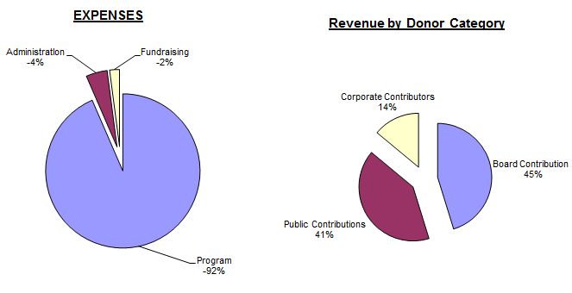

NOTES

* In 2012, Nuru Center board members’ contribution attributed to 45% of overall revenue. This is a testament to the commitment the board has to the cause.
* The biggest expense for 2012 (64.2%) was for the capital expense to purchase a farm per our mid-range goals towards self-sustainability
* The percentage of administration costs went down. Moreover, these costs are covered 100% by board member contributions ensuring that 100% of the public donations and corporate sponsorships goes towards program costs
* The fundraising cost is only 2.0% which is well below industry standards which is a good thing.
* Nuru Center had $0 in salary expenses because 100% of work both in the United States and in Kenya was done on volunteer basis.

|  |  |
| --- | --- |
| **ASSETS** |  |
| Cash at Hand | $3,520.85 |
| Pledges Receivable | $3,000.00 |
| **Total Assets** | **$6,520.85** |
|  |  |
| **LIABILITIES** |  |
| Elimu | $2,700.00 |
| **Total Liabilities** | **$2,700.00** |
|  |  |
| **Net Assets** |  |
| Unrestricted | $3,520.85 |
| Temporary Restricted | $3,000.00 |
| Permanent Restricted | $0.00 |
| **Total Net Assets** | **$6,520.85** |
| **Total Liabilities and Net Assets** | $9,220.85 |

### Notes:

* Liabilities listed are mainly towards the 2013 costs of Elimu Scholarship for the existing students
* Pledges Receivable constitutes amounts pledged to Nuru Center for Elimu Scholarship by the associated children sponsors and through the AT&T United Way giving campaign. .

# Board Members and Volunteers

# Nuru Center would like to recognize the people who make sure the organization was running and functioning optimally on a day to day basis. This consists of the board members and volunteers. Thank you for your continued support and commitment to our mission!

### Board Members

# You will find the full profiles of our board on our website. Below are the current board members of Nuru Center

# Shem Orwenyo – Executive Director & Founder

# Gladys Orwenyo – Director, Treasurer, & Founder

# Jennifer Brown – Director

# Angela Karanja – Director, Marketing, PR, & Volunteer Management

# Christine Kibui – Director, Secretary

# David Kingangi – Director, Information Technology

Nuru Center would also like to recognize and welcome Christine Kibui and David Kingangi as our newest board members.

**Volunteers**

* Anastasia Wandui
* BenKing Kinyua
* Bob Brown
* Camik McNeill
* Christine Kibui
* Dan Kairu
* David King’ang’i
* Eric Nyandat
* Helen Njoki
* Jennifer Njoki
* Mary Bowers
* Mary Mwangi
* Mercy Mutua
* Naomi Lucci
* Naomi Munene
* Nyce Keiyoro
* Peter Njoroge
* Robbie Karume
* Sally Carter
* Tina Wanja
* Tito Mbugua
* Tony Chavez
* Wangari Keiyoro

|  |  |  |
| --- | --- | --- |
| **Donor List**  **$1,000 - $12,000** | **$500 - $999** | **$250 - $499** |
| *Businesses* | *Individuals* | *Businesses* |
| AT&T United Way Employee Giving | Annie Muchogo | MainPro Construction (Eric Maina) |
| Ivory Chevrolet | Christine Kibui | Chavez Graphics (Tony Chavez |
| Kuck Immigration Partners | Idah Mutiso |  |
| Track12 Design Solutions | Jane Githehu | *Individuals* |
|  | Paul Macharia | Alberto & Naomi Lucchi |
| *Individuals* | Rose Kimani | Angela Karanja |
| Bob & Jennifer Brown | Shawn & Amy Toombs | Eric Main |
| Shem & Gladys Orwenyo |  | Peter Nganga |
|  |  | Rose Musyoka |
| **$1 - $249** |  |  |
| *Businesses* |  |  |
| Alpha Courier Of Atlanta (Ralph Kilondu) | |  |
| Frank Tax Services (Francis Kioko) |  |  |
|  |  |  |
| *Individuals* |  |  |
| Adedayo Lawal | Ian Mutua | Nancy Macharia |
| Alexander Salinsky | Irene Mwangi | Nash Alexander |
| Anastasia Wandui | Irene Mworia | Nicole Melonson |
| Andrew McLaughlin | Jackline Morris | Nikki Wilson |
| Andrew Muchemi | Jeff & Mercy Irungu | Njoki Kairu |
| Anne Kangethe | Jennifer Munyao | Paton George |
| Anthony Karoki | John Avitable | Paul Macharia |
| Ben Thiong'o | John Macere | Paulava Carr-Morris |
| Bryan Jilani | John Ngigi | Peter Kamau |
| Camik McNeill | John Rich | Peter Muchina |
| Caroline Musyoka | Juliana Kyalo | Peter Mugo |
| Catherine Muli | Kabugua Mureithi | Peter Nyaga |
| Catherine Odera | Karma Savage | Phinehas Njuno |
| Daniel Katumo | Ka-Ryn Escovedo | Rhoida Motto |
| David Kingangi | Kim Cohen | Robbie Karume |
| David Nti-Berko | Kimberly Johnson | Roger & Brenda Lauer |
| Denys Williams | Lee Muthama | Rosemary Mburu |
| Diane Mukiama | Lucy Gitundu | Salome Carter |
| Eddie Muchori | Lynn & Mary Powell | Sarah Njoroge |
| Fannuel Mugendi | Macharia & Jane Migwi | Shelly Shephens |
| Fern DeArmas | Maggie Tsan | Susan Mwaura |
| Freda Kibuitu | Marcelo Grant | Tawarz Miller |
| Geoffrey Gikonyo | Margaret Fillingim | Tito Mbugua |
| Geoffrey Kimani | Mark Gloor | Veronica Wandui |
| George Brown | Mary Bowers | Victoria Kisekka |
| George Carathimas | Mary Gitata | Vriginia Macharia |
| George Tutu | Mary Kingatua | Zipporah Nyaga |
| Gillian Wanjiru | Mercy Mutua |  |
| Harold Jones | Mildred Orwenyo |  |
| Heiwote Tadesse |  |  |
| Henry Mburu |  |  |