### Nurulogo

**2013 ANNUAL REPORT**

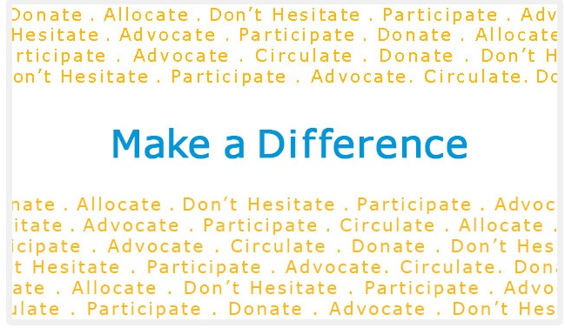

**Word from the Executive Director**:

Over the last six years, Nuru Center has touched many lives. We've seen children grow into young men and women. Shy students become more confident. We've seen hopelessness turned into dreams renewed. Lupita Nyong'o, while accepting her Oscar award, reminded us that every child’s dreams are valid regardless of where they live in the world. That's the message Nuru has carried the last six years and continues to carry as we strive to reach, touch, and change more lives.

2013 was a successful year overall. The Elimu scholarship program added 5 students. We saw two more students successfully complete their secondary school education. In addition, two of our high school graduates admitted to public universities and one enroll in a vocational college through Nuru.

We had yet another successful Holiday Kikapu Giving campaign. The program continues to touch and bless the communities we serve in different ways. Families and children who would have gone hungry during the holidays had food. We boosted the economy for the small scale women who vend farm produce and brighten their holiday as we bought in bulk. Most importantly the program gets Nuru Center on the ground and gives best opportunity to interact with the larger community. This way we get to understand the areas that we need to focus on in order to improve our programs and touch more lives.

Our farm project faced a few hurdles and was not as productive as we envisioned for the first year. Lack of direct road access to the farm was a major hindrance to our operations. In 2014 we are working with the community to build a bridge that will ease access to the farm by car. This will ensure we get material and produce to and from the farm easily. In addition, we plan on building a semi-permanent house for the caretaker and storage on the farm. These things will enable us to fully operate the farm to the level of productivity that will contribute to a decent level of self-sustenance which is one of our long term goals.

With the farm being profitable, we will focus in on our other long term goal of building a community center. The American society is a great example of the benefits of engaging children at an early age to organized extra curricula activities. In addition to constructive ways of spending their time, they get to nurture their talents and learn important social behaviors like leadership and teamwork. We foresee the community center being this resource for children in the rural community we serve in Kenya.

Nuru Center is proud to continue matching towards important strategic goals with the all work being accomplished on 100% volunteer basis. But for us to continue to reach our goals, we will need to hire a few resources to help manage our assets on the ground. This in itself is not a bad thing; it’s another way of changing lives by providing employment. In 2014 we plan on hiring a full time farm caretaker and a part time farm manager. As the caretaker will oversees the day to day activities on the farm, the manager will work strategically to make sure we have a ready market for our produce. All efforts in the USA will continue to be done on a 100% volunteer basis.

The fact that we cannot accomplish anything without our donor and sponsor support is not lost on us. For your support, we’re eternally grateful. The children benefiting from our programs are always reminding us to thank you for being a part of their lives. We don’t take your confidence and trust for granted.

In this annual report, we highlight our accomplishments from the year 2013, showcase the students who are on the Elimu Scholarship as well as share with you our strategic vision for the future. Our doors are always open and if you have any questions, please do not hesitate to contact us. Our goal is to be as transparent as possible because Nuru Center is YOU!

On behalf of the Nuru Center board and beneficiaries, thank you for your continuing support of our mission. You continue to make a real and positive impact on the lives of many children and community at large. Without you, there’s no Nuru Center. We look forward to continuing this partnership changing lives, one child at a time!

Shem Orwenyo

Executive Director and Founder,

**A Scholarship Recipient’s Perspective**

**By Susan Wangui (a Nuru beneficiary from 2009 to 2014)**

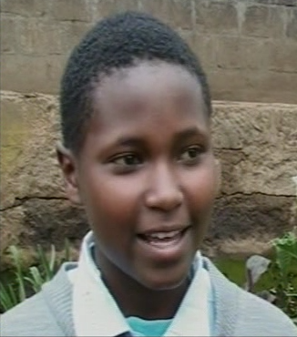I vividly remember the kind of life we had been living, I and my family. You can imagine a kind of life when one meal a day is a problem. The only thing my mother has kept is to hard work so as to meet our daily needs. She’s a casual laborer. When I was in primary school she kept telling us to work hard in school. I have kept faith that one day life will give us a favor. When I was in standard 8 is when dreams of life were starting to flow inside me but the future was still not very promising. Hope kept me moving. Each tear made me wiser and stronger. I knew that nothing could hold me down.

I did my national exams in 2007 (K.C.P.E) and I performed well. Nobody was there to support me. The situation in our home had become worse. Giving up was the last thing I could think of. My teachers were the source of my joy. They kept telling me that education is the key to success. So I could not quit. Despite the humiliation from my classmates who had already joined secondary school, I still believed that I had potential which could become a waste if I continued to stay in the village. I just saw a clearer future. All I wanted is to become a doctor and find cure for incurable diseases like HIV/AIDS. No heartbreak could take away what I am meant to be.

I went back to school and repeated standard 8. There is something I used to do, I still do and will always do; bow my head and pray for my life. I kept hope alive. When I was almost giving up, there was a whisper from my inner self telling to hold just a little longer. I finally did my national exams for the second time. This time around I had hope than before; hope to join high school and fulfill the dreams of my life, change my family’s lifestyle, make my mother proud, be a good example to girls like me who are giving up in life because each tear brought me closer and closer to my dreams. And the last dream I held and still hold is to the change the society I come from.

I first heard about Nuru Center through my teacher who I was very much close to. I applied and I was awarded the scholarship. I was grateful and took it as golden chance to get my dreams come true. I now saw myself more than a winner. Nuru Center has given support; especially Jane Mukami who offered to pay for my school, and I mean tuition, books, uniform, and all required school supplies for four years. I can never repay her. What I can do is work hard, making a bright future for me and others behind me. For once in my life I could attend school like any other child. I thank that the uniforms in school made us to be equal. Some of us came from very poor background. This was motivation to work extra hard so that we can break the cycle of poverty. I passed high school and now I am at Chuka University taking Bachelor of Education. Nuru Center has made this possible; they also helped me join university.

This has made my dreams to become sharper. My future now seems clearer. I can’t change the past, but I can plan the future. Nuru Center is a bridge to my clearer and brighter future. I am not defeated. It has brought me closer to my dreams. I am still working hard because the future I am hoping for is within reach. I can’t avoid challenges; the best thing is to use them as stepping stones to greater heights. I know there are many girls out in the villages that do not have means to have their dreams come true. It takes hope, discipline, will power and hard work to unlock the potential within us. I will not mind disappointments because I can see a better future for my life, for my family, a better society and a little heaven here on earth for those who have dreams like me and for those heartbroken by their current situation. No matter how difficult life becomes, I say no, I can’t be held down. I will emerge a winner.

I wish to thank mum, Nuru Center, Jane and everyone who loves and wishes me the best.

# 

Figure 1: Susan and her Nuru sponsor, Jane Mukami

# 2013 Achievements

### The Nuru Center Elimu Scholarship

2013 marked another major milestone for the Elimu Scholarship program. The second wave of Nuru Elimu scholarship recipients graduated from high school. John Kariuki and Jackson Mwangangi successfully completed their high school education. More importantly, we had two of the students from the first wave join public universities and one join a vocational college. Susan Wangui joined Chuka University; Carol Nyanchama joined University of Kabianga while Emily Apuke joined the Nairobi Aviation College.

What does admittance to the public university mean?

* First to name a few; these kids their lives have been changed and they get an opportunity to continue to change for the better – which is our mission.
* Second, they will get university education at a subsidized cost as compared to those going to parallel programs in the same colleges or in private colleges.
* Third and not list, it opened the door for Nuru Center to be able to continue supporting them and fully realizing the change in their lives we sought from day one.

The two students who graduated are John Kariuki (C+) and Jackson Mwangangi (C). John has a marginal chance of being accepted to a public university but we have to wait until September of 2014 to know for sure. Considering that the first two waves of Elimu scholarship were selected solely on need, we consider it a great achievement that seven out of the 8 students selected in those years successfully graduated from high school. We only started incorporating the academic performance consideration on our third year. This gives us hope that we can achieve 100% university admission rate with our future graduating classes.

**Below are the profiles and results of the two graduates:**

**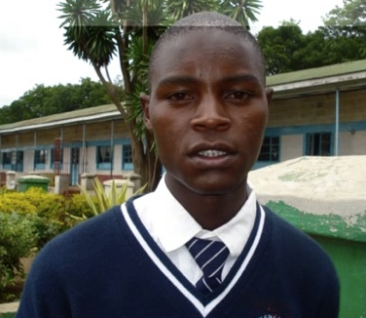John Jane Kariuki**

20 year old John Kariuki lives with his mother and four younger siblings in one small rented room. His mother is a casual laborer and barely makes enough to pay the rent. The children, sometimes, have to go days without food. John started primary school prior to the government introducing free primary education. His mother could not afford the fees, so he had to quit school. Once free primary education was introduced in 2003, John enrolled and repeated 2nd grade at the age of 11. He was older than the students in his grade but he embraced being a leader and became a role model. He has a deep appreciation for health issues and was elected Secretary of the Health Club in his primary school. John is in the 3rd year of secondary school and his dream is to become a neurosurgeon and help his family and members of his community.

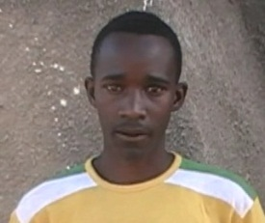 **Jackson K. Mwangangi**

16 year old Jackson Mwangangi and his little sister live with their alcoholic uncle. The children’s parents died when Jackson was three years old. His uncle does not encourage the children’s education. When Jackson was in the 8th grade his uncle wanted him to quit school so that he could work and bring home money. Jackson is in the 3rd year of secondary school and his goal is to finish university and find a job so that he may help other orphans, victims of HIV/AIDS and the mentally challenged.

**Current Elimu Scholarship Recipients**

|  |  |
| --- | --- |
| **susanSusan Wangui (University)**  Susan is a 17 year old who lives with her mother and three siblings. She has never known or met her father. Often she was forced to miss school to care for her younger siblings while her mother looked for work. Susan took and passed her KCPE 2007, but she lacked the money needed to pay for secondary school. However, she was determined to get an education. Susan repeated 8th grade even though she knew her mother could not afford secondary school and didn't know how she would pay for high school if she passed the 2nd time. Susan’s goal is to become a doctor and research a cure for HIV/AIDS in order to help others who are in her situation. Susan graduated with a B+ in Secondary school and was eligible, therefore selected to attend public university system in Kenya. She just finished her 1st year. | **carolCarol Nyanchama (University)**  17 year old Carol is one of 5 siblings born to a single mother, who is disabled and unable to work. In 2005, her mother took her youngest sibling and abandoned Carol and her sister. The girls went to live with an aunt but were expected to work to pay for their share of the rent. Three months later Carol and her sister were kicked out of the house, because they were unable to earn the rent their aunt required. The girls then moved in with a cousin. Every weekend these girls worked all day on a farm to earn money for food. Carol dreams of becoming an engineer and helping others in need. Carol graduated with a B- in Secondary school and was eligible, therefore selected to attend public university system in Kenya. She just finished her 1st year. |
| **Emily Apuke (College)**  emily epukeWhen we selected Emily, she lived with her father and stepmother. Her mother died when she was very young. Emily’s stepmother did not support education, making it difficult for her to study. Because of her test scores, Emily’s teachers encouraged her father to find a way to pay for her secondary education, but he was unable to make enough money for the fees, uniforms and books. On many occasions after joining high school, Emily missed school due to lack of school fees or had to walk 6 miles one way to get to school. Unfortunately, Emily’s dad passed away in 2011 and the step mother did not want to live with her. She was taken in by one of the Nuru volunteers and still stays with them. Emily wants to become a doctor. Emily graduated with a C+. She was not eligible to be admitted to the public university system in Kenya but she enrolled in a vocational college and just finished her 1s year in College. | |
| maureen**Maureen Wairimu**  15 year old Maureen is an orphan. She lives with her grandmother. Her mother died of HIV/AIDS and she has never known her father. Her grandmother ensured that she finished her primary school education but cannot afford to take her through secondary school. Maureen aspires to be a pilot as well as helping orphans; she hopes to build a children home in the process. | **Michael Wang’ombe**  michael15 year old Michael lives with his mother and three siblings. Their father died in 2005 leaving their mother with four young children. The mother is a casual labor who takes on odd jobs to provide for the family. Michael’s older brother dropped out of school in the 6th grade to help provide for the family while his older sister was married young without the chance of finishing her school. Michael will be the first child in his family to have an opportunity to attend secondary school. He aspires to be a computer technician. |
| **Daniel Abuguza**  abuguza14 year old Daniel is an orphan who lives with his aging grandmother. The grandmother also takes care of his elder sister but his younger brother is under the care of an uncle in a different part of the country. Because of poverty, the grandmother cannot always afford to pay for his sister’s secondary school education. She is therefore forced to do casual labor to help out. Daniel is an ambitious boy who aspires to be a doctor | **Maureen Kavindu**  kavinduMaureen is one of five children in her family. With the father moving to the city to sell used clothes for a living and a mother who is sick and spends most of her time in the hospital, the family finds it hard to make ends meet. The older siblings are constantly sent home from school due to lack of school fees because the money the father makes goes towards their mothers medical expenses and basic needs. Maureen aspires to be a teacher or an optician and hopes to use her success to give back to her community. |
| richard_pic**Richard Kimani**  16 year old Richard had already been admitted to secondary school but could not attend due to lack of school fees due to his father’s drukardness and negligence. While he has both parents, his father is a drunk who does not take care of the family leaving the load to his mother. His father works in a hotel where he eats and does not bring the family any food. He spends his salary at the bar. For most days, Richard survives on one meal but managed to pass his national exams the second time around to be admitted to a very good school. He aspires to be a pilot | **Alex** Alex is an orphan whose father passed away from AIDS and the mother is bed ridden with complications of the same. His elder sister and brother did not have a chance to attend high school due to poverty in the family. The elder sister had to get married young and Alex missed many days of school to help feed the rest of his family. Despite all these, Alex passed his KCPE with 344 marks as was selected to a good high school.  . |
| **Hannah** Hannah is also an orphan whose dad passed away in 2004. The mother earns less than $2 a day and has four children to support. The family sometimes sleeps hungry and under the threat of eviction when the mother cannot raise enough funds for rent. Hannah passed her KCPE with 342 marks and was selected to a good high school. | **Purity** Purity comes from a polygamous family. The wives are responsible for taking care of their children. Her mother has 4 other children and her elder sister who's in high school spends a big chunk of time at home because they can't always afford to keep her in school. |
| **Hezron** Hezron comes from a divorced family. The mother earns less than $2 a day. He scored 352 points in KCPE. He was selected to go to a good secondary school. However, his mother could not afford to pay for his school. He therefore decided to go back and repeat class 8 in hope that he would have better luck the following year to get some assistance. Four weeks before the end of the first term, a good Samaritan decided to sponsor a child thru Nuru Center. We found Hezron in class and got him a nice secondary school and enrolled him. Because of this, Hezron has gotten his one year back and his life is on the path that will change it forever. | **Justine** Justine is 1st of 7 children. The parents are poor. He scored 333 points in KCPE. Justine share similar story as Hezron as in he passed well enough, was admitted to a good secondary school but could not attend due to lack school fees. He had decided to attend a local day school that would not have afforded him a good chance to proceed to the university. As with Hezron, a good Samaritan chose to sponsor him later into the first term and Nuru Center worked with his primary school teachers to get him into a good school. |
| **Gilbert Itenyo** Gilbert father passed away in 2013 after a long illness. His older siblings could not complete secondary school education due to lack of school fees. He spends his school breaks working alongside his mother in a quarry breaking rocks to feed the family. This scholarship is his opportunity for him to be the first in his family to complete secondary school education. | **Jecinta Njeri** Jecinta is fourteen years old. Her parents separated in 2006 when the father became too abusive. The father has since not been in their lives. The mother struggles to provide for Jecinta and her two siblings. Jecinta was selected to one of the best schools in the country (Mary Mount in Molo) but her mother couldn’t afford to take her there. |
| **Nicodemus Orora** Nicodemus is a 16 year old orphan. His mother dies of AIDS in 2008. His father resorted to drinking and also died. His uncles forced him to drop out of school in the 5th grade to work. He was determined to get an education and somehow managed to finish his primary school education. He now needs your help to go to the next level. | **Stephen Mutua** Stephen is lucky to have both parents. They live in a semi-arid region in Kenya. His parent’s source of income is odd jobs that don't pay enough to feed the family, let alone pay for school fees. Stephen wants to become a lawyer and to have an opportunity to give back to his community when he becomes successful. |

### Full List of Historical Elimu Scholarship Recipients

|  |  |  |  |  |
| --- | --- | --- | --- | --- |
|  | **Name** | **From** | **To** | **Last Grade of Support** |
|  | Carol Nyanchama | 2009 | Current | University Freshman |
|  | Susan Wangui | 2009 | Current | University Freshman |
|  | Daniel Nyangweso | 2009 | 2012 | 12 |
|  | Josphat Monicah | 2009 | 2012 | 12 |
|  | Emily Apuke | 2010 | Current | College Freshman |
|  | John Kariuki | 2010 | 2013 | 12 |
|  | Jackson Mwangangi | 2010 | 2013 | 12 |
|  | Rebecca Wekesa | 2010 | 2012 | 11 |
|  | Maureen Wairimu | 2011 | Current | 12 |
|  | Michael Wang’ombe | 2011 | Current | 12 |
|  | Anthony Njenga | 2011 | 2012 | 10 |
|  | Janipher Muhonja | 2011 | 2013 | 11 |
|  | Daniel Abuguza | 2012 | Current | 11 |
|  | Maureen Kavindu | 2012 | Current | 11 |
|  | Richard Kimani | 2012 | Current | 11 |
|  | Hannah Wanjiru | 2013 | Current | 10 |
|  | Hezron Njoroge | 2013 | Current | 10 |
|  | Justine Ratemo | 2013 | Current | 10 |
|  | Purity Mwangangi | 2013 | Current | 10 |
|  | Alex Mwaura | 2013 | 2014 | 10 |
|  | Gilbert Itenyo | 2014 | Current | 9 |
|  | Jecinta Njeri | 2014 | Current | 9 |
|  | Nicodemus Orora | 2014 | Current | 9 |
|  | Stephen Mutua | 2014 | Current | 9 |
|  |  |  |  |  |

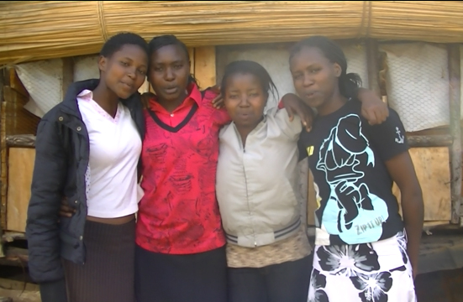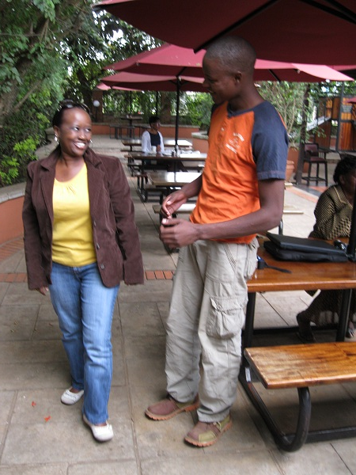

Some of the Nuru Students

John meets his sponsor Idah Mutiso

### Nuru Center Holiday Kikapu Mission

The Holiday Kikapu program is the longest running program under Nuru Center. The outcome for this program has been consistent over the years.

The benefits from the 2013 Kikapu program are as follows:

* We distributed baskets of food to 85 needy families. This is equivalent to over 3400 meals; the baskets can feed a family of four for at least 10 meals. This brings the total meals distributed through this program to over 20,800 to more than 420 families and over 180 patients in the last 7 years.
* Provided an economic boost to the poor mothers and grandmothers at the local market by making lump sum purchases they rarely see. This is turn blesses their families.
* Most importantly we continued to learn a lot about the community we serve from the feedback we get from the volunteers as they talk to the people in these areas. This information is invaluable in helping us understand the needs of the community and in planning future programs that can help the community rise from poverty.

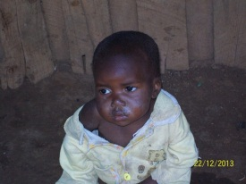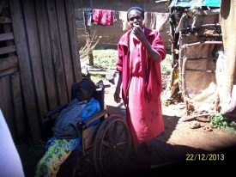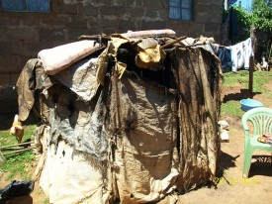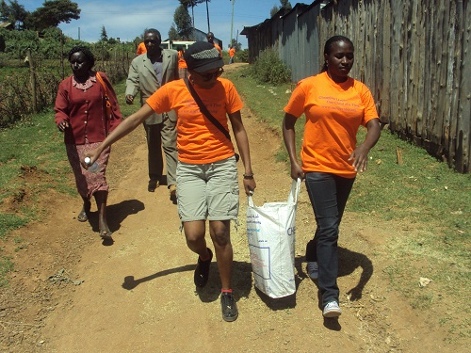

Kikapu giving pictures; clockwise from top left: A hungry child visited, disabled woman and her caretaker, a rug shack acts as home for one of the recipients, Nuru volunteers delivering food

# The Future

### Focus on Children and Sustainability

### The future nonprofit organizations have to be self-sustaining to survive and fulfill their missions. This is a fact that the Nuru Center founders and leadership realized from inception. That’s why Nuru Center was started with a short term, mid-range, and long-term strategic goals.

Nuru Center has achieved most of the short term and mid-range goals. The Elimu Scholarship program is successful and gaining momentum. To this point we have seven students graduating from high school through this program. We have two students advancing to the public universities and one enrolled in a vocational college. At the same time, we still continue keep the doors open for the other graduates who want to pursue higher education to better their lives. We have a mentorship program to support the Elimu Scholarship students. The Holiday Kikapu program has been successful annually.

The Nuru farm was put into use at the beginning of 2013. However, due to some management challenges of the ground, we have only managed to break even on the two cycles of farming. For 2014 we plan on addressing the challenges faced in order to get the farm to the profitability we know is possible. We’ll focus on building a bridge that will make the farm accessible by car so that transporting the produce will be easy. We’ll also build a semi-permanent house and storage on the farm. The farm will allow us to hire a full time caretaker for the farm that will make sure our produce is not stolen. Last but not least, we’ll hire a farm manager and a caretaker. The caretaker will oversee the day to day running of the farm while the manager will strategically manage the farm, supervise the caretaker, and ensure our produce find a market before they are ready to be harvested. We strongly believe in self-sustenance and still believe the farm is the most viable and practical route to this goal.

### We also still strongly believe that for us to make the greatest impact in the communities we serve, we need to start touching the lives of poor children from an early age. We need to provide structured programs that will nurture their talents at an early age while instilling the virtues of academic success to them. That’s why acquiring a one or two acre land that will be more accessible to the community than the farm is still important. On this land, we’ll build a state-of-art community center. The community center will have a library, computer lab, gym, basketball court, and space for meetings. It will be staffed with counselors that children in the community can approach for guidance on anything about life. Based on the funding challenges we’ve had, we have revised the goal for community center to be operation to the end 2016.

# Financials

|  |  |  |
| --- | --- | --- |
| **PUBLIC SUPPORT AND OTHER REVENUE** | | |
| Cash at Beginning of Year | $3,520.85 | 15.56% |
| Public Contributions (net): | $7,403.44 | 32.7% |
| Kikapu Holiday Giving | $2,740.00 | 12.1% |
| Special events (Awareness) | $8,961.35 | 39.6% |
| **Total Revenue** | $22,625.64 | 100.0% |
|  |  |  |
|  |  |  |
| **EXPENSES** |  |  |
| Program Services: |  |  |
| Elimu Scholarship | ($12,400.00) | 75.2% |
| Kikapu Holiday Giving | ($2,000.00) | 12.1% |
| Nuru Farm |  | 0.0% |
| General Administration: | ($1,561.30) | 9.5% |
| Fundraising: | ($538.28) | 3.3% |
| **Total Expenses** | ($16,499.58) | 100.0% |

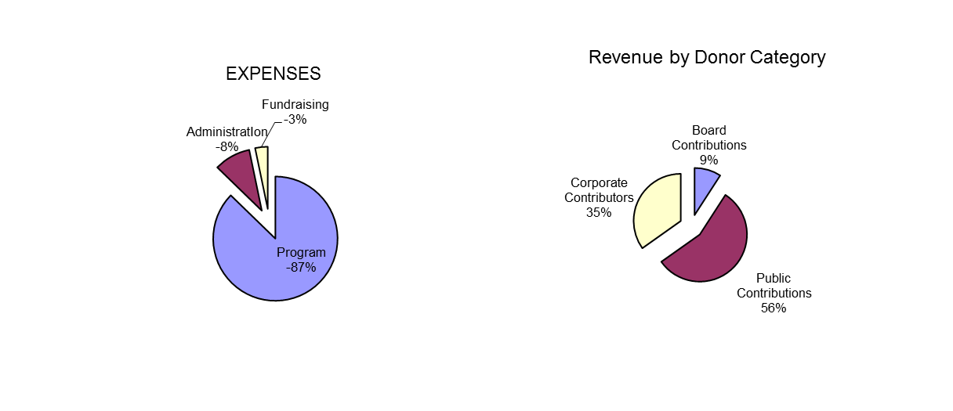

NOTES

* In 2013, Nuru Center four board members’ contribution attributed to 9% of overall revenue. This is a testament to the commitment the board has to the cause.
* The percentage of administration costs remains low compared to industry standards. Moreover, these costs are covered 100% by board member contributions ensuring that 100% of the public donations and corporate sponsorships goes towards program costs
* The fundraising cost is only 3.0% which is well below industry standards which is a good thing.
* Nuru Center had $0 in salary expenses because 100% of work both in the United States and in Kenya was done on volunteer basis.

|  |  |
| --- | --- |
| **ASSETS** |  |
| Cash at Hand | $6,127.21 |
| Pledges Receivable | $2,780.00 |
| **Total Assets** | **$8,907.21** |
|  |  |
| **LIABILITIES** |  |
| Elimu | $3,000.00 |
| **Total Liabilities** | **$3,000.00** |
|  |  |
| **Net Assets** |  |
| Unrestricted | $6,127.21 |
| Temporary Restricted | $2,780.00 |
| Permanent Restricted | $0.00 |
| **Total Net Assets** | **$8,907.21** |
| **Total Liabilities and Net Assets** | $11,907.21 |

### Notes:

* Liabilities listed are mainly towards the 2014 costs of Elimu Scholarship for the existing students
* Pledges Receivable constitutes amounts pledged to Nuru Center for Elimu Scholarship by the associated children sponsors and through the AT&T United Way giving campaign. .

# Board Members and Volunteers

# Nuru Center would like to recognize the people who make sure the organization was running and functioning optimally on a day to day basis. This consists of the board members and volunteers. Thank you for your continued support and commitment to our mission!

### Board Members

# You will find the full profiles of our board on our website. Below are the current board members of Nuru Center

# Shem Orwenyo – Executive Director & Founder

# Gladys Orwenyo – Director, Treasurer, & Founder

# Christine Kibui – Director, Secretary

# David Kingangi – Director, Information Technology

**Volunteers**

* Andrew Mugalla
* Angela Karanja
* Ashley Opinya
* Carol Nganga
* Emily Mutua
* Eric Laval
* Gill Statham
* Jennifer Kelly
* Joel Williams
* Naomi Munene
* Nimu Wangechi
* Njuguna aka DJ Armstar
* Penny Macharia
* Rebecca Ndinda
* Tara Gibson
* Tiffany Opinya
* Tinya Wanja
* Tito Mbugua
* Tony Chavez
* Wangari Keiyoro

|  |  |  |
| --- | --- | --- |
| **Donor List** |  |  |
|  |  |  |
| **$1,000 - $5,000** |  | **$200 - $499** |
| *Businesses* |  | *Businesses* |
| At & t United Way Employee Giving |  | Alpha Courier of Atlanta Inc., |
| Devry University |  | Chavez Graphics |
| Ivory Chevrolet |  | Githehu Consulting |
|  |  | Jambo Landscaping |
| *Individuals* |  | Mawe Stone Consultants, LLC |
| Nunn, Larry & Summer |  | Safari NC |
| Orwenyo, Shem & Gladys |  |  |
|  |  | *Individuals* |
| **$400 - $999** |  | Anonymous |
| *Businesses* |  | Avitabile, John |
| Guard Dogs MFS LLC |  | Couch, Will |
|  |  | Kabaya, Evelyn |
| *Individuals* |  | Kingangi, David |
| Kimani, Rose |  | Macharia , Paul |
| Mbugua, Tito |  | Macharia Virgnia |
| Mutiso, Idah |  | Muchogo, Annie |
| Kibui, Christine |  | Munene, Tony |
| Wanyeki, Priscilla |  | Mutua, Mercy |
|  |  | Odera, Catherine |
|  |  | Statham, Gill |
|  |  | Thomas, Essa |
|  |  |  |
| **$1 - $199** |  |  |
| *Businesses* |  |  |
| Americab Family Insurance | Farm House in the City | Main Pro Construction, LLC |
| Arena Tavern | Frakaz Entertainment | Siracusas NY Pizzeria |
| Boiling Point AC & Cooling | Jambo Tires & Wheels | The Best Notary |
| Captivate Signs |  |  |
|  |  |  |
| *Individuals* |  |  |
| Allen, Clifton | Karangu, Kimani M | Nyandat, Eric |
| Armistar, DJ | Karanja, Angela | Ogote, Elijah |
| Battle, Kenneth | Kariuki, Terry | Orwenyo, Mildred |
| Belcher, Tyrone | Karume, Robbie & Anne | Otieno, Osborne |
| Best, Selina | Katumo, Daniel | Ouma, Mary and Caleb |
| Bland, Aaron | Keiyoro, Wangari | Peter Mwaniki |
| Brady, Chris | Khan, Quranna | Prince, Esiobu |
| Brown, George | Kimani, Charles K | Rackley, Troy |
| Brown, Linda | Kivuitu, Freda | Ransom, Philip |
| Clarke, Ray | Lane, Sheila | Rich, John |
| Cleveland, Kathryn | Laval, Eric | Sagero, Albert |
| Cohen, Kim | Loehlein, Marlene | Salinsky, Alexander |
| Crowe, Andrew | Macere, John | Savage, Dwight |
| Delbeau, John | Makumi, Clare | Schuhr, Elizabeth |
| Dorsey, Tony | Mays, Charles | Sekou, Imhotep |
| Emoghene, Robert | Mburu | Sellers, Travella |
| Evans, Demetrius | McNeill, Camik D | Sessioms, Shawn |
| Fred Ponder | Metcalf, Celeste | Statham, Cynthia |
| Gachunji, Salome | Mitchell, Clarissa | Swann, Sabrina |
| Gichana, Brenda | Mkenya, Charles | Tanner, Minita |
| Gonzalez, Terrence | Motto, Rhoida | Taylor, Clayron |
| Goolsby, Demerritt | Muchai, Miriam | Thaiya, Mark |
| Hargro, Bart | Muchunu, Alex and Mercy | Theuri, William and Janet |
| Harris, Bubba | Mugambi, Christina | Thiongo, Benard |
| Haye, Khadeja | Mugo, Peter | Tsegaye, Endalenesh |
| Holston, Karlton | Muhuri, Erastus | Waithaka, Lucy |
| Jackson, Edward | Munyao, Jennifer | Wallace, Yvonne |
| Johnson, Arthur | Mureithi, Kabugua J | Williams, Althea |
| Judon, Gilda | Muthoga, Peterson K | Williams, Denys |
| Kahiga, Mundia | Mwaura, Susan | Williams, Joel |
| Kairu, Dan | Nganga, Peter | Williams, Maggy |
| Kairu, Njoki | Njoroge, Paul | Williams, Quintin |
| Kanyi, Wanja |  |  |
|  |  |  |