### Nurulogo

**2014 ANNUAL REPORT**



**Word from the Executive Director**:

I look back at the humble beginning of Nuru Center and I am always amazed and humbled by the support we have gotten thus far. Support that has come from friends, work mates, acquaintances and even total strangers who just read about Nuru Center online. It is amazing and humbling to see so many people putting their trust, confidence, hard earned money, time, and reputation behind an organization run by simple, ordinary people seeking to make a change. It is reassuring to see that people can care about others that they have never met and might never meet.

Most importantly it is very fulfilling, wonderful and humbling to see the change we’re impacting on the children Nuru Center sponsors. I make an effort to talk to each student at least twice a year. I have gotten to know them well. I can tell their different personalities from our conversations. I wish every Nuru supporter could get that chance. To hear the joy in the children’s voices as they share their dreams, the pain in their voices when they feel they let Nuru down by not performing better. To see them grow from being shy to being open and confident. These are real lives we’re changing and we could not do it without the support of a lot of good people.

Over the last seven years we have hit many new milestones every year. We have had successes and challenges. The Elimu scholarship has benefitted 31 students over that time. That amounts to 81 annual scholarships and over $60,000 in scholarship funds disbursed. Of the 31 students, 1 forfeited his scholarship, 3 were dropped for not meeting the required academic standards, 1 was dropped for not meeting behavioral standards (but was subsequently given a second chance after he demonstrated he had reformed), 9 have successfully completed their secondary school education, 3 have been admitted to public universities and two are almost completing their vocational studies in colleges.

At the moment our track record shows 5 out of 9 who have completed secondary school have advanced to college or university. This is not a bad ratio, but knowing the students behind them gives me hope that the ratio is going to get even better. Our selection process has improved every year giving us more confidence that we can achieve 100% secondary school completion and 80% advancing to the university by merit. Those who sponsor students can attest to this observation.

Our Kikapu program has maintained a steady run over the same period. Every holiday season we have served over 85 families with over 3,400 meals. The program has positively contributed to the local economy through our support of local farmers and businesses with over $2,500 (Ksh 200,000) spent every December. It has also given Nuru Center an invaluable opportunity for us to know the community we serve better. In 2014 we partnered with the local Red Cross and we look forward to working with them in many facets of our different program. They undeniably have been in the community longer that we have and know the community better than us. This insight will benefit Nuru Center in the long run.

Despite all the success, we still have a few challenges especially with our mid-range and long-range goals. Our farm has not been profitable yet. Our effort to work with the local leaders to make the farm accessible by car has not been very successful. Accessibility is the main reason we have not managed to achieve the goal of generating revenue, but we’re still working with the local community to get that resolved. Achieving accessibility will not only help Nuru Center but the farmers around us as well.

We have not started on our goal to build a community center for the children and youth of the Molo area. This project will require us to tap into grants and corporate sponsorship simply because it requires more capital than we can raise from individuals with the resources we have. All the work we do is on volunteer basis meaning time is hard to come by to see through every idea. That’s why we need more people to volunteer and even join the board to get us moving towards our mid and long-term goals faster.

The future is bright however. We are seeing growing success in our flagship program (Elimu Scholarship) and we’re determined to face the challenges we have successfully. With each year, we’re gaining trust of more people and it’s just a matter of time before we see them stepping up and helping Nuru Center achieve all the goals we have set forth. It’s not easy, but the board members are driven by the passion to change lives. The results are our fuel and we get energized every time we see the students do better or a new donor coming forth and putting their trust in our small organization.

As you go through this report, I will ask you to consider joining forces with Nuru Center. One of the ways you can make a big impact is considering becoming a sustaining supporter by scheduling a monthly donation. No amount is too small. $50, $20 or even $10 dollars a month goes a long way. You can also consider sponsoring a child. Unfortunately the cost of school has gone up. Sponsoring a child is now $720 a year. That’s only $60 a month or $2 a day. There are opportunities for you to volunteer and use your skills and talents to support Nuru Center. We need people with technical, marketing, financial, writing skill to name a few. You can choose to plan and host an event with proceeds benefiting Nuru Center (can be as simple as a brunch with your family and friends). And if you can’t think of a way to support, reach out to us and together we can find a way for you to support and change a life. The difference we seek to make requires all our efforts collectively.

We encourage anyone who has questions about any aspect of Nuru Center to reach out to us and we’ll be glad to answer all questions. We’re committed to running Nuru Center legally and with integrity and transparency. Nuru Center is YOUR organization.

I would like to thank everyone who has ever donated, sponsored an event, sponsored a student, attended our events, volunteered their time and skills, shared a Nuru story on social media and supported Nuru in any way. Our success is really your success. We never take any support for granted. My prayer is that you cup will always overflow with blessings as you continue to bless others.

Shem Orwenyo

Executive Director and Founder

www.nurucenter.org

**A Note from a 2014 Class Graduate**

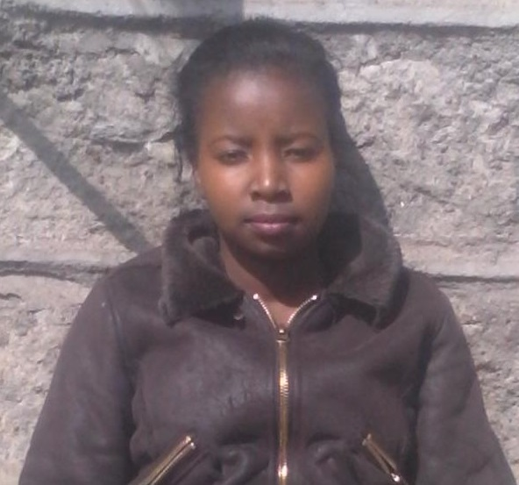My name is Maurine Wanjiru from Kenya. I have been a Nuru Center beneficiary from 2011 when I joined secondary school.

In the short time Nuru Center has assisted me it has turned my life into a paradise since it gave me a bright future. Nuru has been my mother, father and siblings till now.

When I was seven my mother died of HIV/AIDS and she did not leave any information about my father’s whereabouts. I was the only child in the family thus I was left alone. One of my relatives decided to live with me in Molo district. I joined Kambala primary school in Molo. When there, I had no hope of further education since my relative was not well off and the rest were also not well off. I finished my primary school education in 2010 and achieved 352 marks.

Luckily Nuru Center was accepting scholarship application from our school. I met the Nuru coordinator, madam Orwenyo who introduced me to the Nuru board. Nuru Center received me warmly and decided to sponsor me through secondary school education. From then I realized that there is a bright future ahead. I joined Mary Mount Secondary School in 2011 and I finished my secondary school education in 2014.

Through that period Nuru Center provided me with school fees until the last phase of that period. This motivated me to work hard since I was in the best school and I had adequate time to study.

There are times when I was in secondary school that I didn’t attain a good grade. This used to depress me and I felt guilty since I had failed Nuru Center. I expected a great condemnation from the Nuru coordinators after such terms. On the contrary, I received a great deal of encouragement from Shem and madam Orwenyo. This gave me a good reason to take another step ahead and gave me morale to work smarter.

In addition, Nuru Center provided me with lots of revision materials. This helped me revise and boost my grade in the following terms which really improved my performance. At the end my secondary school education I achieved a grade of B+ with 69 points on my K.C.S.E (national secondary school exams). This qualified me to be selected to Moi University for a Bachelor of Science in Agricultural Economics, the choice of my dream.

I thank God for making me know Nuru Center. I do not take that chance for granted. Secondly, I thank my Nuru Center sponsor, Ms. Rose Kimani, for her generous and fruitful efforts to make a bright future for me. I also thank Shem and madam Orwenyo for their advice and encouragement that has taken me this far. Lastly, I thank the Nuru Center board and their supporters for bringing me this far through the hand of God. I am so grateful and I promise never to let you down. You are my family and I love you all.

# 2014 Achievements

### The Nuru Center Elimu Scholarship

2014 marks another year of a successful Elimu Scholarship program. The program added 4 new students who enrolled into their first year of secondary school. It also marked a year when two students successfully finished their secondary school education. That means the students maintained the required grade and behavioral standards through their four years of secondary school. One of the students passed the national exam (KCSE) well enough to be admitted to the university system (a grade of B is required for public university admission). The other student decided to repeat the 12th grade to give himself another chance to be admitted to the university so that he can pursue his dream. We also saw the college and university students continue with their quest to fulfil their dreams. We are excited that more students benefitting from the Nuru Center Elimu Scholarship are advancing to the university system.

What does admittance to the public university mean?

* First to name a few; these kids their lives have been changed and they get an opportunity to continue to change for the better – which is our mission.
* Second, they will get university education at a subsidized cost as compared to those going to parallel programs in the same universities or in private colleges.
* Third and but not least, it opened the door for Nuru Center to be able to continue supporting them and fully realizing the change in their lives we sought from day one.

Below are the profiles and results of the two graduates**:**

**Maureen Wairimu**

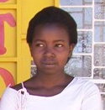Maureen is an orphan. She lives with her grandmother. Her mother died of HIV/AIDS and she has never known her father. Her grandmother ensured that she finished her primary school education but cannot afford to take her through secondary school. As Maureen went through secondary school, she developed a passion for agriculture and started a project in her senior year with a two chicken. By the time she finished she had 32 chickens. She has a passion for helping and has already volunteered with Nuru at different capacities without being pushed.

Maureen graduated with a strong B+ on her national exams. She has been selected to the University of “her dreams, for a course of her dreams”. She will join the university in September 2015 and Nuru Center will continue to sponsor her through her collegiate career.

**Michael Wang’ombe**

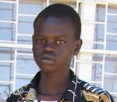Michael lives with his mother and three siblings. Their father died in 2005 leaving their mother with four young children. The mother is a casual labor who takes on odd jobs to provide for the family. Michael’s older brother dropped out of school in the 6th grade to help provide for the family while his older sister was married young without the chance of finishing her school. Michael was the first child in his family to have an opportunity to attend secondary school.

Michael graduated with a C+ on his national exams. While he was waiting for his exams results, he partnered with his older brother and started a bakery that was supplying over 500 loafs of bread a day to the local shops. Michael was not satisfied with his results and decided to repeat his senior year and attempt to take the national exam again in 2015 with an eye at joining the university. While Nuru Center is not sponsoring him in 2015, he still keeps in touch and we hope that he does well so that we can sponsor him for his university studies. He aspires to be a computer technician.

**Current Elimu Scholarship Recipients**

|  |  |
| --- | --- |
| **susanSusan Wangui (University)**  Susan lives with her mother and three siblings. She has never known or met her father. Often she was forced to miss school to care for her younger siblings while her mother looked for work. Susan took and passed her KCPE 2007, but she lacked the money needed to pay for secondary school. However, she was determined to get an education. Susan repeated 8th grade even though she knew her mother could not afford secondary school and didn't know how she would pay for high school if she passed the 2nd time. Susan’s goal is to become a doctor and research a cure for HIV/AIDS in order to help others who are in her situation. Susan graduated with a B+ in Secondary school and was eligible, therefore selected to attend public university system in Kenya. She just finished her 2nd year of university. | **carolCarol Nyanchama (University)**  Carol is one of 5 siblings born to a single mother, who is disabled and unable to work. In 2005, her mother took her youngest sibling and abandoned Carol and her sister. The girls went to live with an aunt but were expected to work to pay for their share of the rent. Three months later Carol and her sister were kicked out of the house, because they were unable to earn the rent their aunt required. The girls then moved in with a cousin. Every weekend these girls worked all day on a farm to earn money for food. Carol dreams of becoming an engineer and helping others in need. Carol graduated with a B- in Secondary school and was eligible, therefore selected to attend public university system in Kenya. She just finished her 2nd year of university. |
| **Emily Apuke (College)**  emily epukeWhen we selected Emily, she lived with her father and stepmother. Her mother died when she was very young. Emily’s stepmother did not support education, making it difficult for her to study. Because of her test scores, Emily’s teachers encouraged her father to find a way to pay for her secondary education, but he was unable to make enough money for the fees, uniforms and books. On many occasions after joining high school, Emily missed school due to lack of school fees or had to walk 6 miles one way to get to school. Unfortunately, Emily’s dad passed away in 2011 and the step mother did not want to live with her. She was taken in by one of the Nuru volunteers and still stays with them. Emily graduated with a C+. She was not eligible to be admitted to the public university system in Kenya but she enrolled in a vocational college studying computer programming and just finished her 2nd year in College. | **Ignatius Omondi (College)**  **22 year old boy. He is the 3rd of 5 in a family headed by a single mother. His story defines resiliency. He moved from secondary school to secondary school due to lack of school fees. But he was obviously determined to get an education. We are proud to partner with Anglohili to offer him a scholarship. He is currently in the 2nd year at Kisumu Polytechnic studying project management.** |
| **Daniel Abuguza**  abuguzaDaniel is an orphan who lives with his aging grandmother. The grandmother also takes care of his elder sister but his younger brother is under the care of an uncle in a different part of the country. Because of poverty, the grandmother cannot always afford to pay for his sister’s secondary school education. She is therefore forced to do casual labor to help out. Daniel is an ambitious boy who aspires to be a doctor | **Maureen Kavindu**  kavinduMaureen is one of five children in her family. With the father moving to the city to sell used clothes for a living and a mother who is sick and spends most of her time in the hospital, the family finds it hard to make ends meet. The older siblings are constantly sent home from school due to lack of school fees because the money the father makes goes towards their mothers medical expenses and basic needs. Maureen aspires to be a teacher or an optician and hopes to use her success to give back to her community. |
| **Richard Kimani**  Richard had already been admitted to secondary school but could not attend due to lack of school fees due to his father’s drukardness and negligence. While he has both parents, his father is a drunk who does not take care of the family leaving the load to his mother. His father works in a hotel where he eats and does not bring the family any food. He spends his salary at the bar. For most days, Richard survives on one meal but managed to pass his national exams the second time around to be admitted to a very good school. He aspires to be a pilot | **Alex** Alex is an orphan whose father passed away from AIDS and the mother is bed ridden with complications of the same. His elder sister and brother did not have a chance to attend high school due to poverty in the family. The elder sister had to get married young and Alex missed many days of school to help feed the rest of his family. Despite all these, Alex passed his KCPE with 344 marks as was selected to a good high school.  . |
| **Hannah** Hannah is also an orphan whose dad passed away in 2004. The mother earns less than $2 a day and has four children to support. The family sometimes sleeps hungry and under the threat of eviction when the mother cannot raise enough funds for rent. Hannah passed her KCPE with 342 marks and was selected to a good high school. | **Purity** Purity comes from a polygamous family. The wives are responsible for taking care of their children. Her mother has 4 other children and her elder sister who's in high school spends a big chunk of time at home because they can't always afford to keep her in school. |
| **Hezron Njoroge** Hezron comes from a divorced family. The mother earns less than $2 a day. He scored 352 points in KCPE. He was selected to go to a good secondary school. However, his mother could not afford to pay for his school. He therefore decided to go back and repeat class 8 in hope that he would have better luck the following year to get some assistance. Four weeks before the end of the first term, a good Samaritan decided to sponsor a child thru Nuru Center. We found Hezron in class and got him a nice secondary school and enrolled him. Because of this, Hezron has gotten his one year back and his life is on the path that will change it forever. | **Justine Ratemo** Justine is 1st of 7 children. The parents are poor. He scored 333 points in KCPE. Justine share similar story as Hezron as in he passed well enough, was admitted to a good secondary school but could not attend due to lack school fees. He had decided to attend a local day school that would not have afforded him a good chance to proceed to the university. As with Hezron, a good Samaritan chose to sponsor him later into the first term and Nuru Center worked with his primary school teachers to get him into a good school. |
| **Gilbert Itenyo** Gilbert father passed away in 2013 after a long illness. His older siblings could not complete secondary school education due to lack of school fees. He spends his school breaks working alongside his mother in a quarry breaking rocks to feed the family. This scholarship is his opportunity for him to be the first in his family to complete secondary school education. | **Jecinta Njeri** Jecinta is fourteen years old. Her parents separated in 2006 when the father became too abusive. The father has since not been in their lives. The mother struggles to provide for Jecinta and her two siblings. Jecinta was selected to one of the best schools in the country (Mary Mount in Molo) but her mother couldn’t afford to take her there. |
| **Nicodemus Orora** Nicodemus is a 16 year old orphan. His mother dies of AIDS in 2008. His father resorted to drinking and also died. His uncles forced him to drop out of school in the 5th grade to work. He was determined to get an education and somehow managed to finish his primary school education. He now needs your help to go to the next level. | **Stephen Mutua** Stephen is lucky to have both parents. They live in a semi-arid region in Kenya. His parent’s source of income is odd jobs that don't pay enough to feed the family, let alone pay for school fees. Stephen wants to become a lawyer and to have an opportunity to give back to his community when he becomes successful. |
| **Beatrice Wanjiru**  **16 years old girl. 2nd of 7 in a family headed by a HIV+ mother who does casual labor for a living. They struggle to pay rent and sleep hungry sometimes. She aspires to be a banker.** | **Jecinta Wairimu**  **14 year old girl. 6th of 8 in a family headed by a single mother. First four siblings never got a high school education due to lack of fees. She aspires to be a journalist.** |
| **Margaret Wangari**  **Margaret is the only child. She lives with her mother and step-father who are casual laborers. They often would not afford rent and were at the mercy of their landlord.** | **Moses Ouma**  **16 year old boy. 2nd of 5 children in a family headed by a single mother. He did his KCPE in 2012 and performed above average. Due to lack of school fees, he decided to repeat and went back two classes. He redid his KCPE in 2014 and passed very well.** |
| **Richard Wangui**  **16 year old boy who is an orphan. He is the second born of three in a family headed by his elder brother who is a casual laborer. He aspires to be a teacher.** |  |

### Full List of Historical Elimu Scholarship Recipients

|  |  |  |  |  |
| --- | --- | --- | --- | --- |
|  | **Name** | **From** | **To** | **Last Grade of Support** |
|  | Carol Nyanchama | 2009 | Current | University sophomore |
|  | Susan Wangui | 2009 | Current | University sophomore |
|  | Daniel Nyangweso | 2009 | 2012 | 12 |
|  | Josphat Monicah | 2009 | 2012 | 12 |
|  | Emily Apuke | 2010 | Current | College (2nd year) |
|  | John Kariuki | 2010 | 2013 | 12 |
|  | Jackson Mwangangi | 2010 | 2013 | 12 |
|  | Rebecca Wekesa | 2010 | 2012 | 11 |
|  | Maureen Wairimu | 2011 | Current | 12 |
|  | Michael Wang’ombe | 2011 | Current | 12 |
|  | Anthony Njenga | 2011 | 2012 | 10 |
|  | Janipher Muhonja | 2011 | 2013 | 11 |
|  | Veronica Chepkemoi | 2012 | 2013 | 11 |
|  | Daniel Abuguza | 2012 | Current | 12 |
|  | Maureen Kavindu | 2012 | Current | 12 |
|  | Richard Kimani | 2012 | Current | 12 |
|  | Hannah Wanjiru | 2013 | Current | 11 |
|  | Hezron Njoroge | 2013 | Current | 11 |
|  | Justine Ratemo | 2013 | Current | 11 |
|  | Purity Mwangangi | 2013 | Current | 11 |
|  | Alex Mwaura | 2013 | 2014 | 11 |
|  | Gilbert Itenyo | 2014 | Current | 10 |
|  | Jecinta Njeri | 2014 | Current | 10 |
|  | Nicodemus Orora | 2014 | Current | 10 |
|  | Stephen Mutua | 2014 | Current | 10 |
|  | Ignatius Omondi | 2014 | Current | College (2nd year) |
|  | Beatrice Wanjiru | 2015 | Current | 9 |
|  | Jecinta Wairimu | 2015 | Current | 9 |
|  | Salome Moraa | 2015 | Current | 9 |
|  | Moses Ouma | 2015 | Current | 9 |
|  | Richard Wangui | 2015 | Current | 9 |

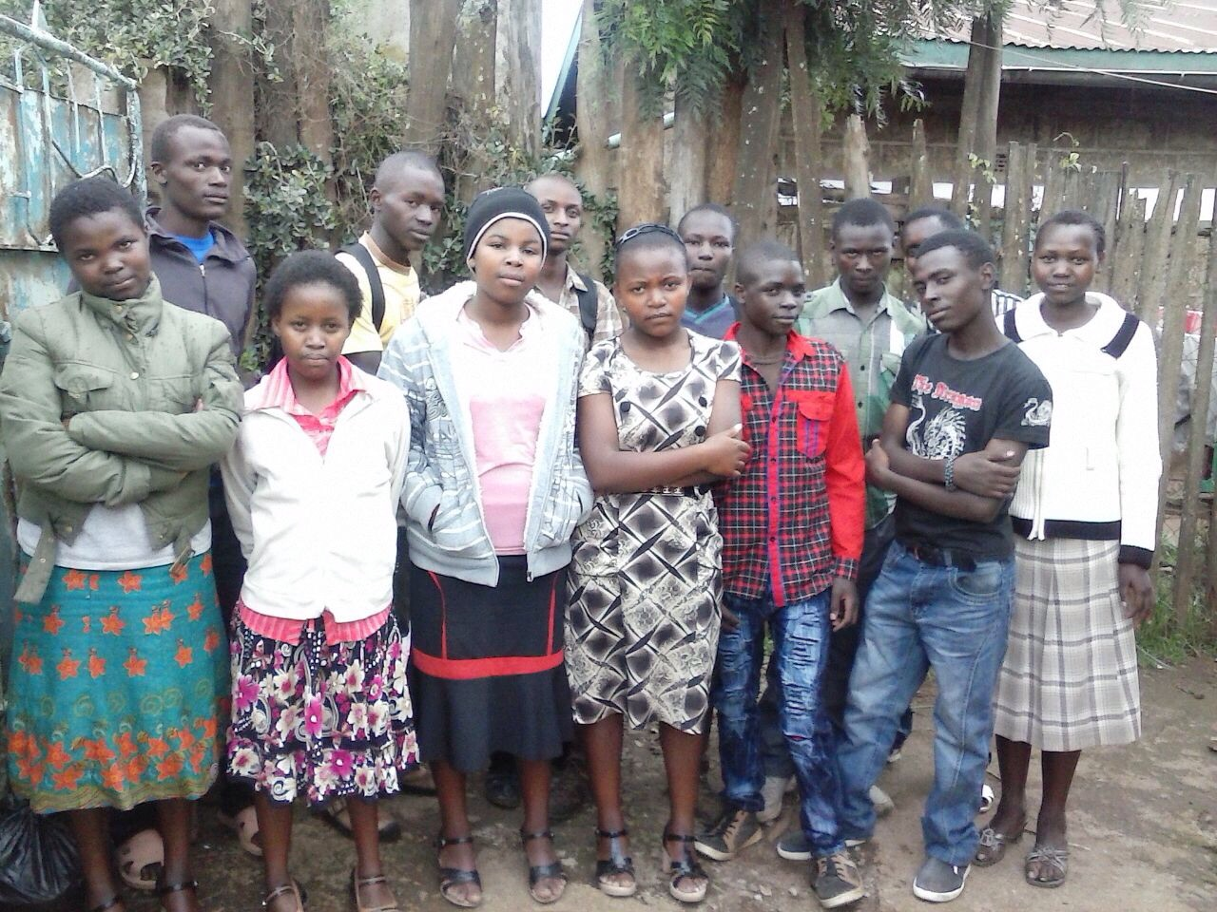

### Nuru Center Holiday Kikapu Mission

The Holiday Kikapu program is the longest running program under Nuru Center. The outcome for this program has been consistent over the years.

The benefits from the 2014 Kikapu program are as follows:

* We distributed baskets of food to 85 needy families. This is equivalent to over 3400 meals; the baskets can feed a family of four for at least 10 meals. This brings the total meals distributed through this program to over 24,200 to more than 600 families and over 180 patients in the last 8 years.
* Provided an economic boost to the poor mothers and grandmothers at the local market by making lump sum purchases they rarely see. This is turn blesses their families.
* Most importantly we continued to learn a lot about the community we serve from the feedback we get from the volunteers as they talk to the people in these areas. This information is invaluable in helping us understand the needs of the community and in planning future programs that can help the community rise from poverty.

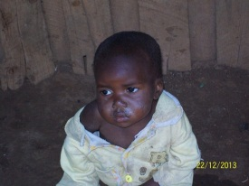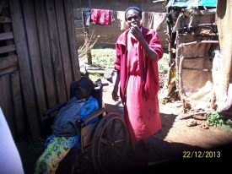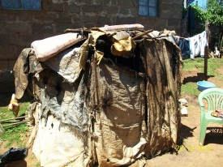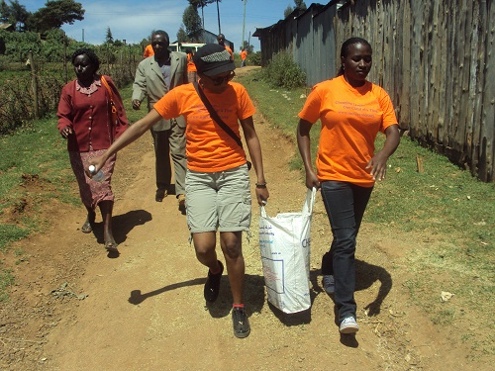

Kikapu giving pictures; clockwise from top left: A hungry child visited, disabled woman and her caretaker, a rug shack acts as home for one of the recipients, Nuru volunteers delivering food

# The Future

### Focus on Children and Sustainability

### We continue to believe that the future nonprofit organizations revolve around generating their own revenue to facilitate self-sustenance. This has been Nuru Center’s strategic goal from inception.

### The Nuru Elimu Scholarship program has been very successful over the years. We’re beginning to it’s fruits with more students in the Nuru program being admitted to the university and others almost finishing their courses in colleges and trade schools. The first Nuru class has two students advancing to the 3rd year of university in 2015 and one joining one of Kenya’s best public universities in 2015. Nuru Center is seeing more people committing to sponsor students going into high school. All these are great strides.

### While we continue to strongly believe education is the key to killing the cycle of poverty in rural Kenya, we also understand that beyond the first 12 years of education, there are many routes to success. That’s why we’re renewing our efforts to build the first community/youth center in the Molo area. The community center structured programs that will nurture the talent of children in rural Kenya at an early age while instilling the virtues of academic success to them. The community center will have a library, computer lab, gym, basketball court, and space for meetings. It will be staffed with counselors that children in the community can approach for guidance on anything about life. Based on the funding challenges we’ve had, we have revised the goal for community center to be operation to the end 2017. To achieve this goal, we need to acquire a piece of land close to the neighborhoods that need it most.

We are still passionate about the Nuru farm project. Our efforts to work with the local leaders to build a bridge that will make not only the farm accessible for Nuru Center but for the local community as well has not bore any results yet. But we’re hopeful and are starting to work with local farmers to ensure that area is accessible by car to make it possible for all farmers in the area to easily get material and produce to their farms. Once this piece of infrastructure is in place, we believe it will allow us to put the farm into permanent use and start generating revenue for the programs.

# Financials

|  |  |  |
| --- | --- | --- |
| **PUBLIC SUPPORT AND OTHER REVENUE** | | |
| Cash at Beginning of Year | $6,127.21 | 25.36% |
| Public Contributions (net): | $10,704.63 | 44.3% |
| Kikapu Holiday Giving | $2,960.00 | 12.3% |
| Special events (Awareness) | $4,370.69 | 18.1% |
| **Total Revenue** | $24,162.53 | 100.0% |
|  |  |  |
|  |  |  |
| **EXPENSES** |  |  |
| Program Services: |  |  |
| Elimu Scholarship | ($12,070.00) | 69.3% |
| Kikapu Holiday Giving | ($2,500.00) | 14.3% |
| Nuru Farm |  | 0.0% |
| General Administration: | ($1,264.62) | 7.3% |
| Fundraising: | ($970.00) | 5.6% |
| Other | ($624.54) | 3.6% |
| **Total Expenses** | ($17,429.16) | 100.0% |

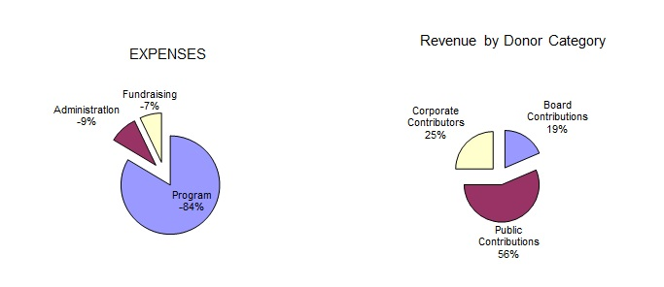

NOTES

* In 2014, Nuru Center four board members’ contribution attributed to 19% of overall revenue. This is a testament to the commitment the board has to the cause.
* The percentage of administration costs remains low compared to industry standards. Moreover, these costs are covered 100% by board member contributions ensuring that 100% of the public donations and corporate sponsorships goes towards program costs
* The fundraising cost is only 7.0% which is well below industry standards which is a good thing.
* Nuru Center had $0 in salary expenses because 100% of work both in the United States and in Kenya was done on volunteer basis.

|  |  |
| --- | --- |
| **ASSETS** |  |
| Cash at Hand | $6,733.37 |
| Pledges Receivable | $3,000.00 |
| **Total Assets** | **$9,733.37** |
|  |  |
| **LIABILITIES** |  |
| Elimu | $5,400.00 |
| **Total Liabilities** | **$5,400.00** |
|  |  |
| **Net Assets** |  |
| Unrestricted | $6,733.37 |
| Temporary Restricted | $3,000.00 |
| Permanent Restricted | $0.00 |
| **Total Net Assets** | **$9,733.37** |
| **Total Liabilities and Net Assets** | $15,133.37 |

### Notes:

* Liabilities listed are mainly towards the 2014 costs of Elimu Scholarship for the existing students
* Pledges Receivable constitutes amounts pledged to Nuru Center for Elimu Scholarship by the associated children sponsors and through the AT&T United Way giving campaign.

.

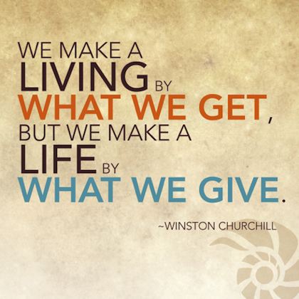

# Board Members and Volunteers

# Nuru Center would like to recognize the people who make sure the organization was running and functioning optimally on a day to day basis. This consists of the board members and volunteers. Thank you for your continued support and commitment to our mission!

### Board Members

# You will find the full profiles of our board on our website. Below are the current board members of Nuru Center

# Shem Orwenyo – Executive Director & Founder

# Gladys Orwenyo – Director, Treasurer, & Founder

# Christine Kibui – Director, Secretary

# David Kingangi – Director, Information Technology

**Volunteers**

* Anastasia Wandui
* Andrew Mugala
* Angela Karanja
* Ashley Opinya
* Carol Nganga
* Christina Brown
* Diana Spencer
* Emily Mutua
* Evans Muchene
* Naomi Munene
* Nelson Muriuki
* Priscilla Ngigi
* Robbie Karume
* Tiffany Opinya
* Tina Wanja
* Tito Mbugua
* Tony Chavez
* Vance Ongaga
* Veronica Wandui

|  |  |  |
| --- | --- | --- |
| **Donor List** |  |  |
| **$1,000 - $5,000** |  | **$200 -$499** |
| Businesses |  | *Businesses* |
| AT&T United Way Employee Giving |  | Mtoto Africa Inc. |
|  |  | 254 Atlanta Open |
| Individuals |  | Barbara Kihumba Law Firm LLC |
| Orwenyo, Shem & Gladys |  | Farm House in the City |
| Nunn, Thomas & Summer |  | Mawe Stone |
|  |  | Main Pro Construction, LLC |
| **$500 - $999** |  | Lanet Enterprises |
| *Businesses* |  | Seagate Freight |
| Jambo Tires |  |  |
|  |  | *Individuals* |
| *Individuals* |  | George, Paton |
| Kibui, Christine |  | Mbugua, Tito |
| Hunyu, Hannah |  | Mutava, Pauline |
| Wanyeki, Muthoni |  | Wandui, Veronica |
| Kimani, Rose |  | Giovinazzo, Emily |
| Kinyua, Jane |  | Partin, Sara |
|  |  | Avitabile, John |
|  |  | Ngigi, Priscilla |
|  |  | Ouma, Caleb & Mary |
|  |  | Ngaga, Peter |
|  |  |  |
|  |  |  |
|  |  |  |
| **$1 - $199** |  |  |
| *Businesses* |  |  |
| Chavez Graphics | Amerikenya, LLC | Alpha Courier of Atlanta Inc. |
| Anglohili Inc. | Tides Inc. |  |
|  |  |  |
| *Individuals* |  |  |
| Mutiso, Idah | Muriuki, Nelson | Mwangi, Terry |
| Muchunu, Alex & Mercy | Kimundi, Lucy | Theuri, William & Janet |
| Ochoi, Caroline & Phil | Karanja, Angela | Kuria, James |
| Odera, Catherine | Kairu, Jennifer | Mugo, Peter |
| Rocky, Kenneth | Paveglio, Damon | Dickey, Seline |
| Orwenyo, Mildred | Acevedo, Mary & Memo | Mwangi, Mary T |
| Williams, Maggy | Wachira, Ann | Nyandat, Eric |
| Escovedo, Ka-Ryn | Egbe, Judith | Macharia, Wairimu |
| Mutua, Mercy | Mungai, Jimmy & Ruth | Mwangi, Stephen & Peninah |
| Rori, Angela | Waithaka, Lucy | Keiyoro, Wangari |
| Munene, Naomi | Partin, Linda | Macharia, Paul |
| Kamau, Margaret & Stephen | Nyareru, Lilian | Muchemi, Monica |
| Kioko, Frank | Kabaya, Evelyne | Yerramilli, Durga |
| Kingangi, David | Nganga, Caroline | Durbin, Drew |
| Njoroge, Paul & Hellen | Njeri, Catherine | Kiragu, Shiro |
| Kahiga, Mundia | Achungo, Louis | Opiyo, George |
| Macharia, Virginia | Wallace, Yvonne | Karume, Robbie |
| Tae, Jae-Do | Nti-Berko, David | Spencer, Diana |
| Lane, Sheila Muthoni | Njoroge, Peter & Wakini | Kariuki, Jacqueline |
| Kanyua, Esther | Kabugua, Mureithi & Teresa | Mwangi, Nduta |
| Kinyua, Benson | Odongo, Mildred | Mwangi, Carolyn & James |
| Mbugua, Margaret | Johnson, Kimberly M. | Ndegwa, Timothy |
| Mutua, Emily | Muchemi, Andrew | Mitchell, Maureen |
| Kimani, Geoffrey | Munene, Loise | Kahio, Monica |
| Gloor, Mark | McNeill, Camik | Kariuki, Terri |
| Wachira, Tonny | Munyao, Jennifer Nduku | Kinyua, Angel |
| Muchene, Christine | Macere, John |  |

Appendix

Below is an example of the requirements for admission to one of the schools Nuru students were admitted to. It will give you an idea of the cost for secondary school education. Conservatively use the exchange rate of $1 = Ksh 95 to convert the cost to USD.

