Thank you for your interest in supporting the Nuru Center mission. All of us wish we can do more: donate more money, volunteer more hours, sponsor more kids etc. However, circumstances do not always allow us to do so. Well, now you have an opportunity to do more regardless of your circumstances. You can help by being a Nuru Center ambassador and reaching out to your family, friends, and co-workers and help Nuru Center raise more money that will go towards its mission. Simply follow the following 11 steps and increase you impact!

Create Your Campaign

- Register on the site by going to http://nurucentergala.org
- Click Register link at the bottom right of the side bar
- Select a username and enter your email address (an email will be sent to your email address for confirmation. It will include your username and password)
- Using the link and information on the email, log in to site
- Update your password to something you can remember and click update profile
- Go to http://www.nurucentergala.org/causes/raisemoneyfornuru and you should see the following screen
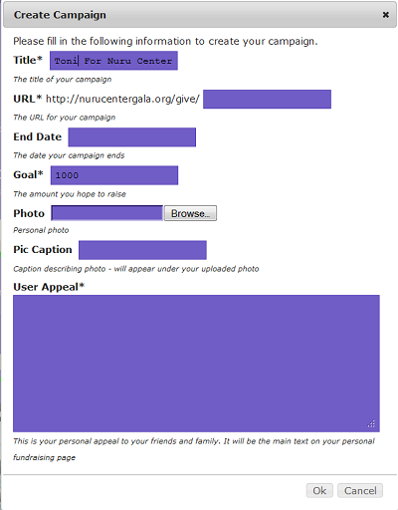

- Enter the details. Below are the description of the fields
  - Title – The title for your campaign page
  - URL – the link you will send to your friends, family, and colleagues. You need to enter the last part only. E.g. toni. The result url will be http://nurucentergala.org/give/toni
  - End date – date you will be ending the campaign
  - Goal – the amount of money you wish to raise by the end date
  - Photo (optional) – You can select an photo of yourself or an appropriate photo to be displayed on your campaign page
  - Pic Caption (optional) – The description that will appear under your photo. E.g if you put a photo of yourself, you can simply enter your name on the pic caption
  - User Appeal - This is where you will state your appeal. An appeal is a statement and story that will let the people you are trying to reach out to know why you are involved and how they can help (in this case helping you reach your pledged goal).
** You will end up with something like this
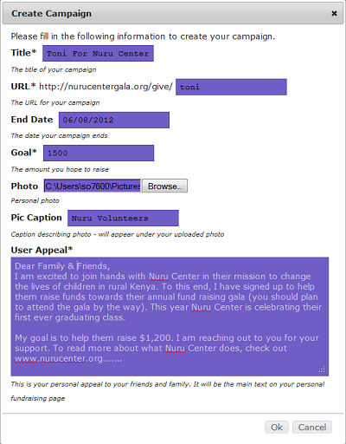
- Click Ok
- The following screen will pop up… Click Ok (PS: If you hadn’t logged in or registered, you will be prompted to login or register. Simply follow Steps 1-4 to register or simply login in with your existing username and password.
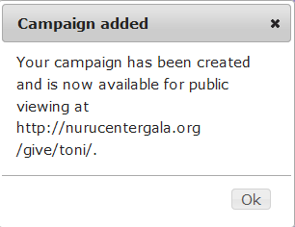
Your url and the url you will need to send to your friends in email will be http://nurucentergala.org/give/toni/ (toni being the last part you entered in the form)
- Your personal campaign page will look like this:
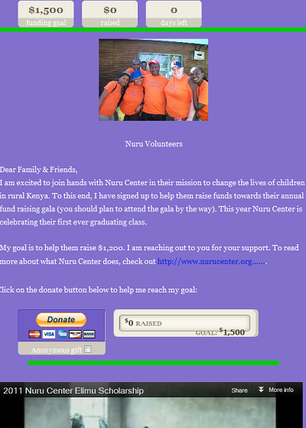
- Reach out to your family, friends and co-workers via email, facebook, twitter and start your journey of raising funds.

Edit Your Campaign
To edit your campaign follow the following steps
- Login to the site by going to http://nurucentergala.org (skip to step 4 if you are already logged in)
- Click Login at the bottom right on the side bar
- Login using your existing username and password
- Type in your personal campaign url (in our example: http://nurucentergala.org/give/toni)
- You will get an edit button below your “wall of honor” section. Click this button and update any information as needed
- Click Ok to submit your Changes.

If you have any questions, please email nurugala@nurucenter.org.

